Table S1: Specimen list with corresponding locality, species, and sex.

Sample | Locality | Species |  | Sex
1005 - MN 23233 | BA - Belmonte |  | S. xanthosternos | F
1006 - MN 23240 | BA - Faz. Sucurui, Itajuípe |  | S. libidinosus | F
356 - MG 21764 | RO - UHE de Samuel, rio Jamari, afl. dir. rio Madeira |  | S. apella | F
357 - MG 21765 | RO - UHE de Samuel, rio Jamari, afl. dir. rio Madeira |  | S. apella | F
358 - MG 21766 | RO - UHE de Samuel, rio Jamari, afl. dir. rio Madeira |  | S. apella | M
359 - MG 26521 | PA - Oriximiná, Rio Saracazinho |  | S. apella | F
360 - MG 21494 | PA - Oriximiná, Cachoeira Porteira |  | S. apella | M
361 - MG 21497 | PA - Oriximiná, Cachoeira Porteira |  | S. apella | M
812 - MZUSP 6317 | MT - Rio Aricá, Fazenda Arigá |  | S. cay | M
813 - MZUSP 6319 | MT - Rio Aricá Fazenda Arigá |  | S. cay | M
814 - MZUSP 6324 | MT - Cáceres |  | S. cay | F
816 - MZUSP 2582 | BA - Senhor do Bonfim |  | S. xanthosternos | M
817 - MZUSP 2583 | BA - Senhor do Bonfim |  | S. xanthosternos | M
818 - MZUSP 2585 | BA - Senhor do Bonfim |  | S. xanthosternos | F
819 - MZUSP 2586 | BA - Senhor do Bonfim |  | S. xanthosternos | M
820 - MZUSP 5915 | MG - Baixo Rio Suaçuí |  | S. robustus | M
821 - MZUSP 5916 | MG - Baixo Rio Suaçuí |  | S. robustus | M
822 - MZUSP 5919 | MG - Baixo Rio Suaçuí |  | S. robustus | F
823 - MZUSP 5920 | MG - Baixo Rio Suaçuí |  | S. robustus | F
825 - MZUSP 11095 | GO - Anicuns - Fazenda Água Clara |  | S. libidinosus | F
826 - MZUSP 11096 | GO - Anicuns - Fazenda Água Clara |  | S. libidinosus | M
827 - MZUSP 11097 | GO - Anicuns - Fazenda Água Clara |  | S. libidinosus | M
828 - MZUSP 5321 | AM - Eirunepé, Santa Cruz, Rio Eiru |  | S. apella | M
829 - MZUSP 5318 | AM - Eirunepé, Santa Cruz, Rio Eiru |  | S. apella | F
830 - MZUSP 779 | AM - Rio Juruá |  | S. apella | M
831 - MZUSP 10542 | AM - Eirunepé |  | S. apella | F
832 - MZUSP 19622 | SP - São Vicente, Estação Engenheiro Ferraz |  | S. nigritus | F
833 - MZUSP 6015 | SP - Porto Cabral, Rio Paraná |  | S. nigritus | F
834 - MZUSP 6887 | SP - Boracéia |  | S. nigritus | M
835 - MZUSP 19620 | SP - São Vicente, Estação Engenheiro Ferraz |  | S. nigritus | M
3035 - MN 5676 | ES - Santa Teresa. Colonia do Milanez, 25 de julho |  | S. nigritus | F
3036 - MN 5719 | ES - Santa Teresa, São João de Petrópolis - Mata da Escola |  | S. nigritus | F
3037 - MN 5724 | ES - Santa Teresa, São João de Petrópolis - Mata da Escola |  | S. nigritus | F
3038 - MN 5712 | ES - Santa Teresa, São João de Petrópolis - Mata da Escola |  | S. nigritus | F
3039 - MN 5731 | ES - Santa Teresa, São João de Petrópolis - Mata da Escola |  | S. nigritus | F
3040 - MN 5684 | ES - Santa Teresa, São João de Petrópolis - Mata da Escola |  | S. nigritus | M
3041 - MN 5681 | ES - Santa Teresa. Colônia do Milanez, 25 de julho |  | S. nigritus | M
3042 - MN 5699 | ES - Santa Teresa, São João de Petrópolis - Mata da Escola |  | S. nigritus | M
3044 - MN 5701 | MG - Além Paraíba , Fazenda São Geraldo |  | S. nigritus | M
3203 - MN 23321 | PE - Serrita |  | S. libidinosus | F
3204 - MN 4619 | MG - Faz. Cabacal, Uberaba |  | S. libidinosus | F
3205 - MN 4572 | MG - Araguari |  | S. libidinosus | F
3206 - MN 4585 | MG - * |  | S. libidinosus | F
3207 - MN 4526 | MG - Araguari |  | S. libidinosus | F
3208 - MN 4618 | MG - Faz. Pântano, Patos de Minas |  | S. libidinosus | M
3209 - MN 4624 | MG - Faz. Violeta; Estrella do Sul, Cascalho Rico |  | S. libidinosus | M
3210 - MN 4587 | MG - Araguari |  | S. libidinosus | M
3211 - MN 4586 | MG - Faz. Cabacal, Uberaba |  | S. libidinosus | M
3212 - MN 4575 | MG - Araguari |  | S. libidinosus | M
3223 - MN 21189 | ES - Faz. Samambaia, Conceição da Barra |  | S. robustus | M
3224 - MN 21194 | ES - Mata São João, Vila São Domingos |  | S. robustus | M
3225 - MN 21218 | BA - Sapucaieira, Alcobaça |  | S. robustus | M
3226 - MN 21214 | BA - Mucurizinho, Mucuri |  | S. robustus | M
3227 - MN 21217 | BA - Sapucaieira, Alcobaça |  | S. robustus | F
3228 - MN 21209 | BA - Mucurizinho, Mucuri |  | S. robustus | F
3229 - MN 21219 | BA - Sapucaieira, Alcobaça |  | S. robustus | F
3230 - MN 21222 | BA - Sapucaieira, Alcobaça |  | S. robustus | F
3238 - MN 23228 | MG - Belmonte, Belo Horizonte |  | S. xanthosternos | M
3249 - MN 4831 | MS - Maracaju |  | S. cay | F
3250 - MN 4633 | MT - Cuiabá |  | S. cay | F
3251 - MN 4826 | MT - Cuiabá |  | S. cay | F
3252 - MN 8502 | MT - Posto Jacaré; Baixo Kuluene, Alto Xingu |  | S. cay | M
3253 - MN 23357 | MT - Rio Arraias, Alto Xingu |  | S. cay | M
3254 - MN 4833 | MS - Maracaju |  | S. cay | M
1508-5788 | MS - Salobra |  | S. cay | M
1510-19696 | MT - Rio Piquiri |  | S. cay | F
1520-19680 | MS - Porto XV de Novembro; Faz. Santa Bárbara |  | S. cay | F
1526-4299 | MS - Salobra |  | S. cay | M
1527-6323 | MT - Bom Jesus do Araguaia; Palmeiras |  | S. cay | M
1529-3363 | MS - Corumbá |  | S. cay | F
1533-3361 | MS - Corumbá |  | S. cay | M
1537-3360 | MS - Corumbá |  | S. cay | F
1538-3770 | MS - Coxim |  | S. cay | F
1542-28539 | MS - Brasilândia; Faz. Barma |  | S. cay | F
1544-3775 | MS - Miranda |  | S. cay | M
1548-4317 | MS - Corumbá |  | S. cay | M
1551-6964 | MT - São Domingos, Rio das Mortes |  | S. cay | F
1556-6960 | MT - São Domingos, Rio das Mortes |  | S. cay | M
1559-6963 | MT - São Domingos, Rio das Mortes |  | S. cay | F
1562-6970 | MT - São Domingos, Rio das Mortes |  | S. cay | M
1567-6961 | MT - Porto Guaporé, Rio 7 de Setembro |  | S. cay | M
1576-10716 | PA - Lagoa Ipavu, Parque do Xingu |  | S. cay | M
1581-6321 | MT - Rio Aricá, Fazenda Aricá |  | S. cay | F
1583-2883 | MA - Miritiba |  | S. apella | M
1585-2745 | MA - Miritiba |  | S. apella | F
1587-2488 | MA - Boa Vista |  | S. libidinosus | M
1591-2364 | GO - Faz. Esperança; Rio Araguaia |  | S. libidinosus | F
1592-2365 | GO - Faz. Esperança; Rio Araguaia |  | S. libidinosus | M
1593-10642 | GO - Goiânia |  | S. libidinosus | F
1595-7907 | GO - Jataí; Faz. Santa Adéllia |  | S. libidinosus | M
1596-7905 | GO - Jataí; Faz. Santa Adéllia |  | S. libidinosus | M
1597-1430 | GO - Ponte Ipê Arcado (Sobre Paranaíba) |  | S. libidinosus | F
1599-21325 | PA - Cachoeira do Espelho; Rio Xingu |  | S. apella | M
1600-10546 | PA - Bravo, Rio Amazonas |  | S. apella | M
1602-19595 | PA - Fordlândia |  | S. apella | F
1604-19591 | PA - Fordlândia |  | S. apella | M
1608-19604 | PA - Urucurituba; Rio Tapajós |  | S. apella | M
1610-19608 | PA - Urucurituba; Rio Tapajós |  | S. apella | F
1613-5753 | PA - Caxiricatuba; Rio Tapajós |  | S. apella | M
1616-5118 | PA - Caxiricatuba; Rio Tapajós |  | S. apella | F
1618-5123 | PA - Aruã; Rio Arapiuns |  | S. apella | F
1620-5674 | PA - Aruã; Rio Arapiuns |  | S. apella | M
1625-4291 | PA - Boim |  | S. apella | M
1627-25452 | PA - Boca do Bacajá |  | S. apella | M
1629-19635 | SC - São Francisco do Sul; Figueira do Pontal |  | S. nigritus | F
1633-19639 | SC - São Francisco do Sul; Figueira do Pontal |  | S. nigritus | M

Table S2: Anatomical definitions of homologous mandibular landmarks.

Mandible
1 | Anterior portion of the canine alveolus
2 | Posterior portion of the canine alveolus
3 | Anterior incision of the first molar
4 | Posterior incision of the second molar
5 | Contact point between the mandibular corpus variable and the coronoid process
6 | Apex of the coronoid process
7 | Midpoint between landmarks 5 and 6
8 | Posterior projection of the coronoid process
9 | Point of maximum curvature of the coronoid process
10 | Maximum curvature of the mandibular notch
11-12 | Anterior and posterior portions of the condylar process, respectively
13 | Boundary between the condylar process and the gonial angle
14 | Upper boundary of the gonial angle
15 | Maximum inferior curvature of the gonial angle
16 | Maximum curvature between the mandibular corpus and the gonial angle
17-18 | Vertical projections of landmarks 2 and 3.

Text S1: Detailed protocol for correcting spatial autocorrelation in morphometric data.
To address the potential bias related to spatial autocorrelation, the ODMAP protocol ("Overview, Data, Model, Assessment and Prediction"; Zurell et al., 2020) has been used, which provides a standardized approach to ensure that sample independence is maintained throughout model development. One key recommendation on this is the correction of non-independent samples, as spatial autocorrelation in residuals can lead to inaccurate predictions (Dormann et al., 2007). Thus, ODMAP analyzes the spatial autocorrelation of residuals, ensuring that the dependency between nearby locations is properly modeled (Dormann et al., 2007). To assess whether spatial autocorrelation was present in the sample locations, a spatial dependence analysis was performed, calculating geographical distances using the dist function from the "stats" package (R Core Team, 2024). These distances were then log-transformed to adjust the data scale. The residual and shape distances were also calculated, applying log transformations when necessary (Cohen, 1988). The correlation between geographical distances and residuals was assessed using the Mantel test (Legendre & Fortin, 2010) and the cor.test function. Additionally, the "mpmcorrelogram" package (Legendre & Legendre (1998, pp. 736-738) cited in De la Cruz et al., 2017) was employed to compute a correlogram, which allowed the analysis of spatial autocorrelation at different spatial scales (classes) and its Moran’s tests statistics (Jin & Lee, 2014). The Pearson method (Benesty et al.,2009) was used to examine correlations between geographical distances and both residual and shape distances.

Figure S1: The alternative (consensus) hypothesis for Sapajus phylogeny.

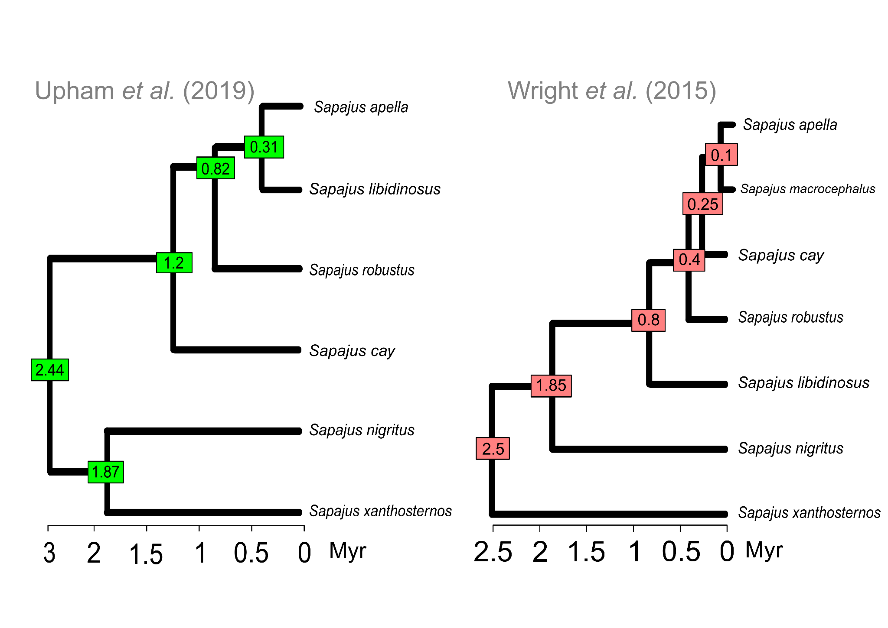

Figure S2: Principal component analysis (PCA) of mandibular shape by sex.

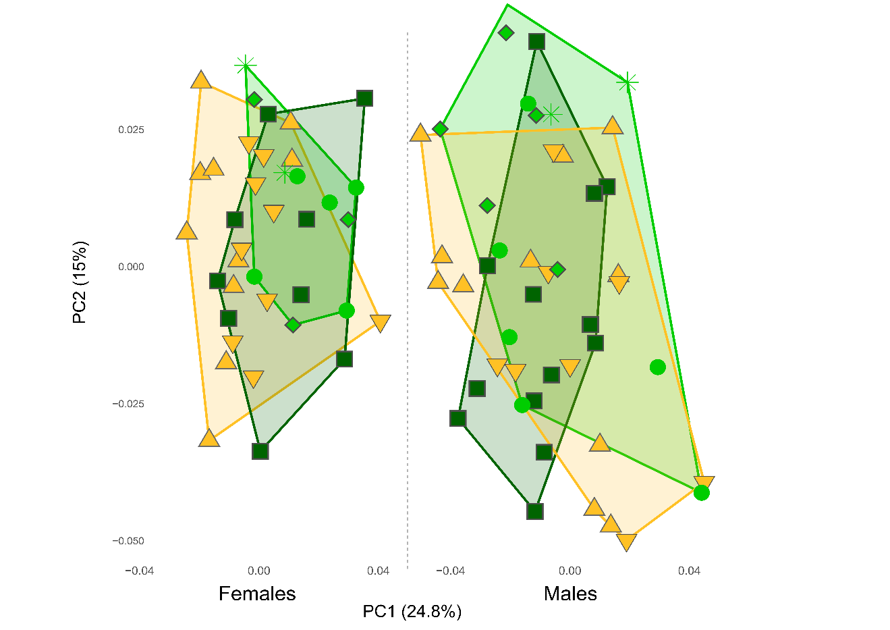

Figure S3: Spatial correlogram of morphometric data.

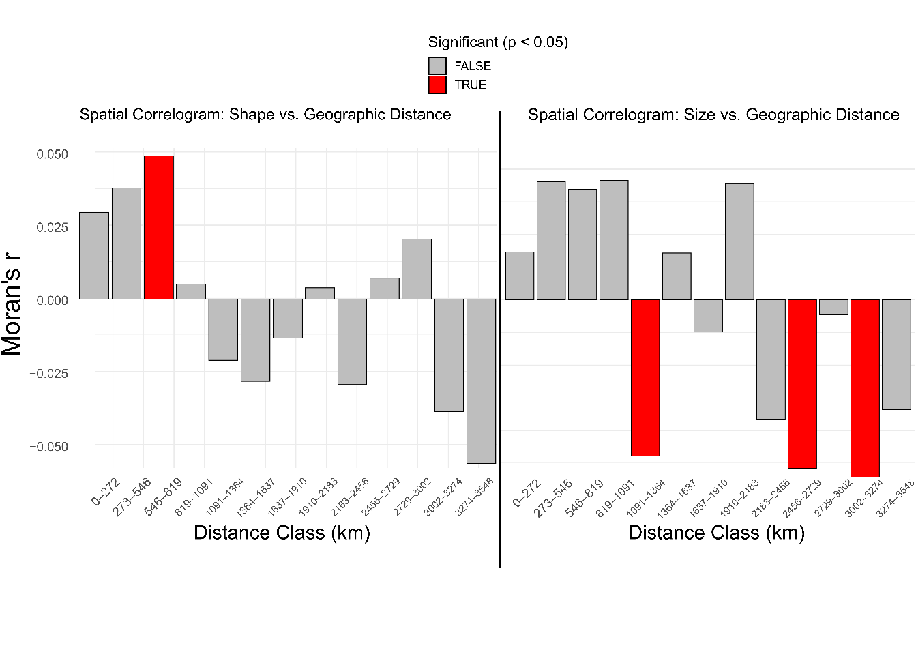

Table S3: Distance class properties and Mantel statistics for size and shape matrices.

Size-residuals |  |  |  |  |  |  |  |  | Shape distance
class | distance.range (Km) |  |  |  | rM | p |  | p.Bonferroni | class |  | distance.range (Km) |  |  | rM | p |  | p.Bonferroni
1 | 0 | - | 2.509 | 0.014 |  |  | 0.225 | 0.225 | 1 | 0.000 |  | - | 272.872 | 0.025 |  | 0.126 | 0.126
2 | 2.509 | - | 5.017 | 0.040 |  |  | 0.036 | 0.072 | 2 | 272.872 |  | - | 545.743 | 0.034 |  | 0.063 | 0.126
3 | 5.017 | - | 7.526 | 0.031 |  |  | 0.121 | 0.363 | 3 | 545.743 |  | - | 818.615 | 0.063 |  | 0.013 | 0.039
4 | 7.526 | - | 10.034 | 0.028 |  |  | 0.158 | 0.632 | 4 | 818.615 |  | - | 1091.487 | -0.007 |  | 0.425 | 1.700
5 | 10.034 | - | 12.543 | -0.040 |  |  | 0.076 | 0.380 | 5 | 1091.487 |  | - | 1364.358 | -0.019 |  | 0.227 | 1.135
6 | 12.543 | - | 15.051 | 0.011 |  |  | 0.335 | 2.010 | 6 | 1364.358 |  | - | 1637.230 | -0.030 |  | 0.162 | 0.972
7 | 15.051 | - | 17.56 | -0.002 |  |  | 0.464 | 3.248 | 7 | 1637.230 |  | - | 1910.102 | 0.002 |  | 0.479 | 3.353
8 | 17.56 | - | 20.068 | 0.035 |  |  | 0.094 | 0.752 | 8 | 1910.102 |  | - | 2182.974 | -0.007 |  | 0.399 | 3.192
9 | 20.068 | - | 22.577 | -0.037 |  |  | 0.078 | 0.702 | 9 | 2182.974 |  | - | 2455.845 | -0.021 |  | 0.225 | 2.025
10 | 22.577 | - | 25.085 | -0.056 |  |  | 0.033 | 0.330 | 10 | 2455.845 |  | - | 2728.717 | -0.004 |  | 0.458 | 4.580
11 | 25.085 | - | 27.594 | -0.015 |  |  | 0.258 | 2.838 | 11 | 2728.717 |  | - | 3001.589 | 0.019 |  | 0.249 | 2.739
12 | 27.594 | - | 30.102 | -0.048 |  |  | 0.049 | 0.588 | 12 | 3001.589 |  | - | 3274.460 | -0.036 |  | 0.130 | 1.560
13 | 30.102 | - | 33.611 | -0.032 |  |  | 0.168 | 2.184 | 13 | 3274.460 |  | - | 3548.332 | -0.052 |  | 0.097 | 1.261

Table S4: Phylogenetic generalized least squares (PGLS) models of climatic predictors on mandibular size.

Model | Variable | Beta | P | AIC | Model | Variable | Beta | P | AIC
Brownian + PCNMs | BIO12 | 0.455 | 0.009 | -118.923 | Pagel's + PCNMs | BIO18 | 0.276 | 0.007 | -124.576
Brownian + PCNMs | BIO10 | -0.356 | 0.030 | -116.656 | Pagel's + PCNMs | BIO1 | -0.165 | 0.109 | -124.573
Brownian + PCNMs | BIO18 | 0.289 | 0.039 | -115.893 | Pagel's + PCNMs | BIO6 | -0.123 | 0.265 | -123.383
Brownian + PCNMs | BIO1 | -0.331 | 0.091 | -115.156 | Pagel's + PCNMs | BIO12 | 0.320 | 0.025 | -122.465
Brownian + PCNMs | BIO8 | -0.284 | 0.077 | -115.029 | Pagel's + PCNMs | BIO17 | 0.254 | 0.047 | -121.367
Brownian + PCNMs | BIO17 | 0.248 | 0.063 | -114.996 | Pagel's + PCNMs | BIO14 | 0.242 | 0.056 | -120.956
Brownian + PCNMs | BIO16 | 0.275 | 0.113 | -114.559 | Pagel's + PCNMs | BIO10 | -0.233 | 0.061 | -120.925
Brownian + PCNMs | BIO5 | -0.268 | 0.120 | -114.452 | Pagel's + PCNMs | BIO9 | -0.196 | 0.006 | -120.535
Brownian + PCNMs | BIO3 | 0.304 | 0.176 | -114.387 | Pagel's + PCNMs | BIO5 | -0.204 | 0.094 | -120.202
Brownian + PCNMs | BIO14 | 0.218 | 0.095 | -114.273 | Pagel's + PCNMs | BIO8 | -0.199 | 0.103 | -120.064
Brownian + PCNMs | BIO9 | -0.267 | 0.204 | -114.037 | Pagel's + PCNMs | BIO16 | 0.219 | 0.129 | -119.766
Brownian + PCNMs | BIO11 | -0.241 | 0.262 | -113.717 | Pagel's + PCNMs | BIO11 | -0.183 | 0.088 | -119.690
Brownian + PCNMs | BIO6 | -0.227 | 0.295 | -113.570 | Pagel's + PCNMs | SOILMOIST | 0.181 | 0.123 | -119.639
Brownian + PCNMs | BIO13 | 0.205 | 0.233 | -113.441 | Pagel's + PCNMs | BIO13 | 0.156 | 0.273 | -118.690
Brownian + PCNMs | BIO4 | -0.183 | 0.392 | -113.173 | Pagel's + PCNMs | HUMID | 0.134 | 0.393 | -118.567
Brownian + PCNMs | HUMID | 0.164 | 0.431 | -113.009 | Pagel's + PCNMs | BIO7 | 0.024 | 0.888 | -118.023
Brownian + PCNMs | SOILMOIST | 0.161 | 0.233 | -112.959 | Pagel's + PCNMs | BIO2 | 0.028 | 0.858 | -117.936
Brownian + PCNMs | BIO7 | -0.017 | 0.944 | -112.640 | Pagel's + PCNMs | BIO3 | 0.127 | 0.461 | -117.914
Brownian + PCNMs | BIO2 | 0.124 | 0.508 | -112.608 | Pagel's + PCNMs | BIO4 | -0.035 | 0.831 | -117.824
Brownian + PCNMs | BIO15 | -0.132 | 0.326 | -112.478 | Pagel's + PCNMs | BIO19 | -0.036 | 0.806 | -117.778
Brownian + PCNMs | BIO19 | -0.089 | 0.652 | -112.474 | Pagel's + PCNMs | BIO15 | NA | NA | NA
Brownian + PCNMs | NPP | 0.051 | 0.747 | -111.938 | Pagel's + PCNMs | NPP | NA | NA | NA
Brownian Motion | BIO12 | 0.564 | 0.000 | -123.744 | Pagel's lambda | BIO12 | 0.445 | 0.001 | -127.425
Brownian Motion | BIO18 | 0.367 | 0.004 | -119.072 | Pagel's lambda | BIO16 | 0.350 | 0.015 | -122.883
Brownian Motion | BIO10 | -0.434 | 0.010 | -118.012 | Pagel's lambda | BIO10 | -0.341 | 0.025 | -121.724
Brownian Motion | BIO16 | 0.398 | 0.013 | -117.404 | Pagel's lambda | BIO4 | -0.341 | 0.037 | -121.489
Brownian Motion | BIO4 | -0.420 | 0.022 | -116.680 | Pagel's lambda | BIO17 | 0.317 | 0.010 | -121.232
Brownian Motion | BIO3 | 0.476 | 0.028 | -116.643 | Pagel's lambda | BIO18 | 0.283 | 0.025 | -121.198
Brownian Motion | BIO13 | 0.332 | 0.043 | -115.331 | Pagel's lambda | BIO13 | 0.294 | 0.044 | -121.017
Brownian Motion | BIO8 | -0.327 | 0.049 | -115.124 | Pagel's lambda | BIO3 | 0.340 | 0.053 | -120.962
Brownian Motion | SOILMOIST | 0.263 | 0.049 | -114.693 | Pagel's lambda | HUMID | 0.297 | 0.029 | -120.620
Brownian Motion | BIO2 | 0.289 | 0.066 | -114.511 | Pagel's lambda | BIO14 | 0.294 | 0.017 | -120.545
Brownian Motion | BIO19 | -0.296 | 0.075 | -114.421 | Pagel's lambda | BIO8 | -0.274 | 0.063 | -120.411
Brownian Motion | BIO1 | -0.296 | 0.148 | -113.736 | Pagel's lambda | SOILMOIST | 0.247 | 0.049 | -120.386
Brownian Motion | BIO17 | 0.222 | 0.105 | -113.474 | Pagel's lambda | BIO5 | -0.208 | 0.166 | -118.864
Brownian Motion | BIO6 | -0.281 | 0.185 | -113.466 | Pagel's lambda | NPP | 0.212 | 0.108 | -118.698
Brownian Motion | HUMID | 0.259 | 0.198 | -113.266 | Pagel's lambda | BIO1 | -0.210 | 0.225 | -118.645
Brownian Motion | BIO14 | 0.199 | 0.138 | -112.997 | Pagel's lambda | BIO7 | -0.129 | 0.381 | -117.516
Brownian Motion | BIO9 | -0.202 | 0.350 | -112.615 | Pagel's lambda | BIO9 | -0.084 | 0.638 | -117.465
Brownian Motion | NPP | 0.180 | 0.248 | -112.420 | Pagel's lambda | BIO6 | -0.082 | 0.635 | -117.335
Brownian Motion | BIO7 | 0.161 | 0.430 | -112.244 | Pagel's lambda | BIO11 | -0.041 | 0.818 | -117.328
Brownian Motion | BIO5 | -0.161 | 0.360 | -112.161 | Pagel's lambda | BIO19 | -0.098 | 0.526 | -117.197
Brownian Motion | BIO11 | -0.093 | 0.671 | -111.933 | Pagel's lambda | BIO2 | 0.109 | 0.450 | -117.152
Brownian Motion | BIO15 | -0.062 | 0.649 | -111.017 | Pagel's lambda | BIO15 | -0.092 | 0.483 | -117.147
Figure S4: PGLS Regression of BIO10 and mandibular size.
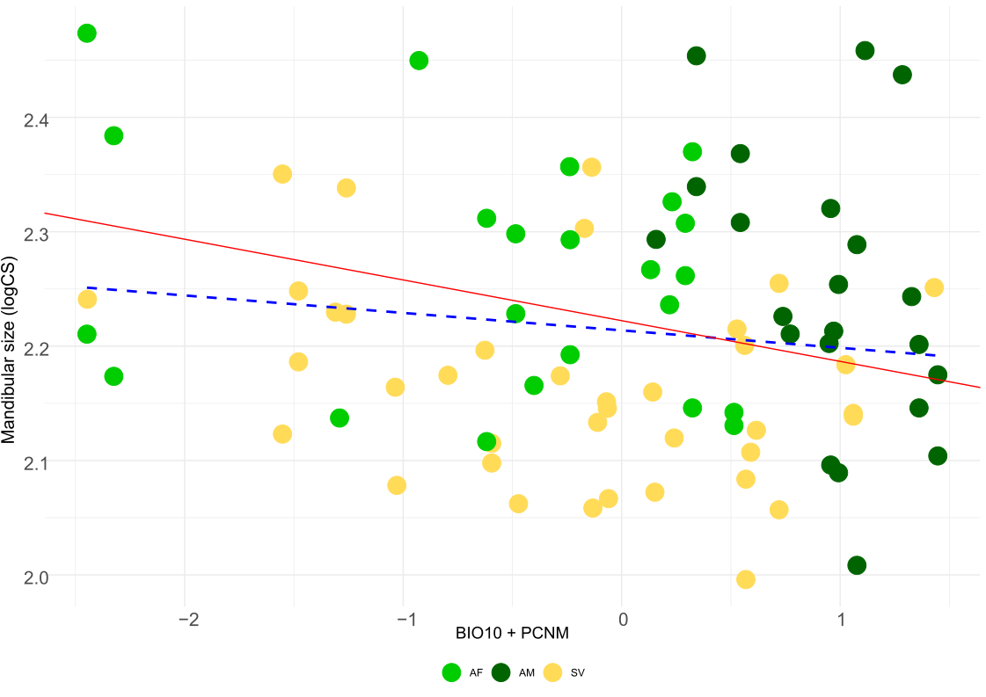

LITERATURE CITED

Benesty, J., Chen, J., Huang, Y., Cohen, I. (2009). Pearson Correlation Coefficient. In: Noise Reduction in Speech Processing. Springer Topics in Signal Processing, vol 2. Springer, Berlin, Heidelberg. https://doi.org/10.1007/978-3-642-00296-0_5
Cohen, J. (1988). Statistical power analysis for the behavioral sciences (2nd ed.). Hillsdale, NJ: Lawrence Erlbaum Associates.
De la Cruz, M., M., Ambiente, M., & Marino, M. R. (2017). Package ‘mpmcorrelogram’.
Dormann, C. F., et al. (2007). Methods to account for spatial autocorrelation in the analysis of species distributional data: A review. Ecography, 30(5), 609-628.
Jin, F., & Lee, L. (2014). On the bootstrap for Moran’s I test for spatial dependence. Journal of Econometrics, 184(2), 295-314.
Legendre, P., & Fortin, M.-J. (2010). Comparison of the Mantel test and alternative approaches for detecting complex multivariate relationships in the spatial analysis of genetic data. Molecular Ecology Resources, 10(5), 831-844.
Zurell, D., et al. (2020). A standard protocol for reporting species distribution models. Ecography, 43(9), 1261-1277

